**GNSS Missing Data Interpolation Software Based Kriged Kalman Filter Model**

***User Manual***

Written by Ning Liu

October 2016

Central South University (CSU)

China

Preface

Data missing is an inevitable problem of GNSS coordinate time series, while some GNSS time series analysis methods need complete data, such as Wavelet, FFT, ICA, spectrum analysis. Therefore, missing data should be complemented before GNSS time series analysis. Normally used complementing methods can be divided to three groups: 1) Conventional interpolated methods (e.g. Polynomial interpolation, Lagrange interpolation, Spline interpolation, etc.). They only work with random data missing, and do not perform well if data have gaps; 2) Singular spectrum analysis-based (SSA) method. As it does not require priori parameter of time series and it works well with missing gaps, it is widely used in interpolating GNSS missing data. But its result is too smooth and it cannot keep high frequency signal of GNSS series; 3) The iterative empirical orthogonal function-based (EOF-based) method. It is another method which does not require any prior knowledge of the behavior of the time series and it considers offsets and colored noise in real GPS coordinate time series. However, all of these methods are only based on single point, without considering spatial correlations.

To interpolate GNSS missing data more precisely, the *GNSS Missing Data Interpolation Software* (GMIS) packages, a dynamic spatio-temporal missing data interpolation method based on Kriged Kalman Filter (KKF), is developed. This *User Manual* will introduce how to use this software in detail.

Contents

1. Installation 4

2. Software introduction 5

2.1 GMIS 5

2.2 SemiVarigFit 7

2.3 Interpolation Mode 9

3. Examples 10

3.1 Example of GNSS missing data interpolation in SCIGN 10

3.2 Example of GNSS missing data interpolation in Antarctic Peninsula 15

4. Contact 19

# Installation

There are two ways to use this software：

* Download the software compressed folder from the Internet；
* Decompress the compressed folder;
* Verify the computer is installed with the MATLAB Compiler Runtime (MCR) for version 8.1 (R2013a);
* Open ‘GMIS\software\exe’ folder and double click GMIS.exe
* Download the software compressed folder from the Internet;
* Decompress the compressed folder;
* Add ‘GMIS\software\source code’ folder into MATLAB search path;
* Type GMIS in the MATLAB command window;

# Software introduction

This software mainly contains three graphical user interfaces (GUI): *GMIS* (main GUI), *SemiVarigFit* and *InterpolationMode*.

*GMIS* is to load GNSS data, save the filter and interpolated result, display the three dimensional source and result GNSS data, and invoke other subGUI.

*SemiVarigFit* is to calculate the empirical semi-variogram value and fit a semi-variogram function. The empirical semi-variogram value and fitting result are also displayed in this GUI.

*InterpolationMode* is to set some parameters of EM algorithm and KKF model.

The operating process is as follows:



If GNSS sites are sparse, or you do not want to set parameters in the *SemiVarigFit* GUI, you can interpolate missing data in the *InterpolationMode* GUI directly after loading data in the *GMIS* GUI. We use two examples to explain how to use this software.

1. GMIS

The display figure and subfunctions of *GMIS* GUI are shown as follows:

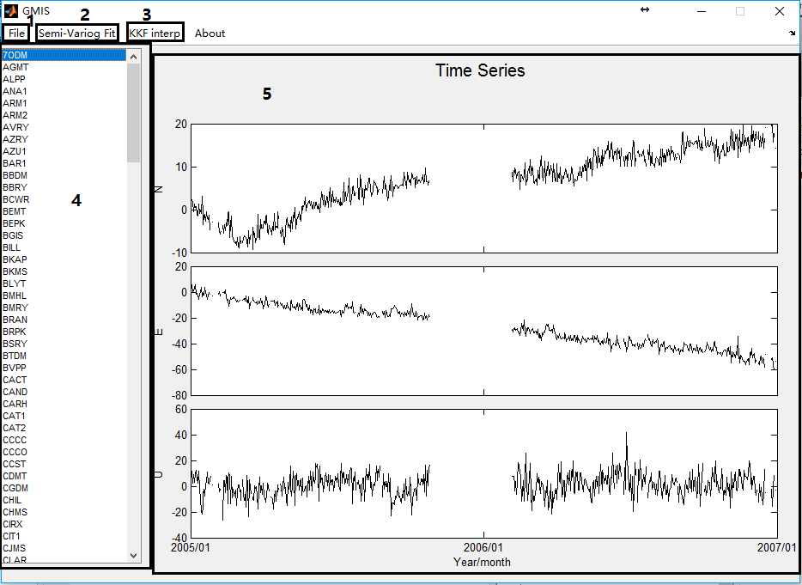

|  |  |  |
| --- | --- | --- |
| ID | Control Type | Purpose |
| 1 | menu | to load data, save result and close the software.  File-Open(submenu): to load data.  File-Save(submenu): to save filter and interpolated results.  File-Close (submenu): to close the software. |
| 2 | menu | invoke the *SemiVarigFit* GUI. |
| 3 | menu | invoke the *InterpolationMode* GUI. |
| 4 | listbox | to display the site name.  After loading data, all sites will be displayed in the list box. And if one site is selected, its source N/E/U series will be displayed in the three boxes (black line) on the right. Also, if missing data is interpolated, the filter and interpolated result will be displayed in the three boxes automatically (red line). |
| 5 | axes | to display source time series and interpolated results. |

Only data in the required format can be input. We provide four data examples in the compressed file. Data file is a MATLAB mat file with only one struct. The struct has a casual name, but seven fixed fields. You cannot change the field name or delete any field. Field names and descriptions are as follows:

|  |  |
| --- | --- |
| Field | Description |
| day | a $T×1$ double matrix (T is the length of monitoring date). It records date of monitoring. Its element is number of days from 00-Jan-0000; |
| dn | a $T×m$ double matrix (m is the number of GNSS site). Its column vector is each GNSS site series in the N (North) direction during the monitoring date. The first day’s value should be translated into 0. The missing data should be filled by NaN (Not a Number). The series in the N direction can be put into an empty matrix if it is not concerned. But this field should not be deleted. |
| de | a $T×m$ double matrix. Its element is similar to that of the ‘dn’ field, but in the E (East) direction. |
| du | a $T×m$ double matrix. Its element is similar to that of the ‘dn’ field, but in the U (Up) direction. |
| x | a $m×1$ double matrix. Its element shows the x-coordinate of the GNSS site, i.e., the longitude. |
| y | a $m×1$ double matrix. Its element shows the y-coordinate of the GNSS site, i.e., the latitude. |
| site | a $m×4$ char matrix. Its row vector is the name of the GNSS site. |

The result data file are also a MATLAB mat file with only one struct. The struct contains all the fields of the input data, and four more fields for saving the interpolated result. The added fields are as follows:

|  |  |
| --- | --- |
| Field | Description |
| interp_dn | a $T×m$ double matrix. Its column vector is each GNSS site filter and interpolated series in the N direction during the monitoring date. |
| interp_de | a $T×m$ double matrix. Its element is similar to that of the ‘interp_dn’ field, but in the E direction. |
| interp_du | a $T×m$ double matrix. Its element is similar to that of the ‘interp_dn’ field, but in the U direction. |
| VarigPar | a struct; It contains three fields named ‘VariogFitPar_N’ / ’ VariogFitPar_E’ / ‘VariogFitPar_U’, which save semi-variogram function fitting result in three directions. |

1. SemiVarigFit

The display figure and subfunctions of the *SemiVarigFit* GUI are shown below:

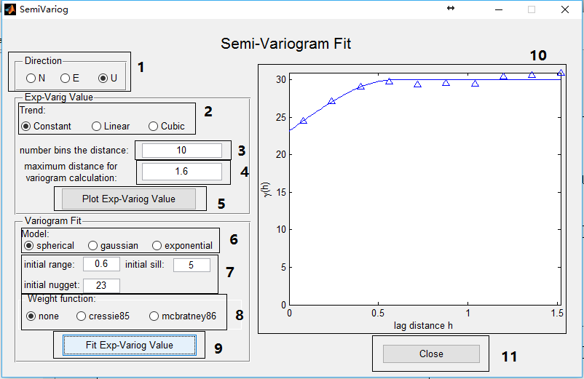

|  |  |  |
| --- | --- | --- |
| ID | Control Type | Purpose |
| 1 | radiobutton | to select the direction of the empirical semi-variogram value you want to calculate and fit the semi-variogram function. |
| 2 | radiobutton | to select space trend in the selected direction. Commonly used space trends are constant, linear and quadratic. |
| 3 | edit | number of distance groups (default = 20) |
| 4 | edit | maximum distance for the variogram calculation (default = maximum distance in the dataset / 2) |
| 5 | pushbutton | invoke a function to calculate the empirical semi-variogram value and display it in the right box panel. |
| 6 | radiobutton | to select the semi-variogram model. Commonly used models are spherical, gaussian and exponential. |
| 7 | edit | to set the initial range (default = []), initial sill(default = []) and initial nugget(default = [], which means the user wants to fit a model without nugget). |
| 8 | radiobutton | to select weight function. 'None' (default). 'cressie85' and 'mcbratney86' require the observation number of per empirical semi-variogram value to calculate weight, and the observation number can be the output while calculating empirical semi-variogram value. |
| 9 | pushbutton | Call a variogramfit function to fit the empirical semi-variogram value and display it in the right box panel. Once the fit is completed, the fit result will be saved automatically. |
| 10 | axes | to display the empirical semi-variogram value (triangle) and fitted semi-variogram function (line). |
| 11 | pushbutton | Close the GUI display. |

1. Interpolation Mode

The display figure and its subfunctions of the *InterpolationMode* GUI are shown below:

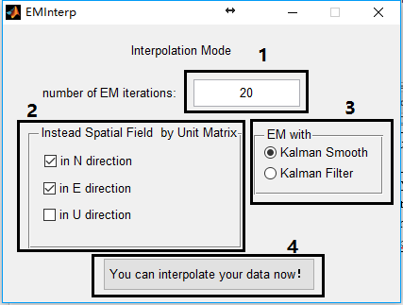

|  |  |  |
| --- | --- | --- |
| ID | Control Type | Purpose |
| 1 | edit | Number of EM iterations |
| 2 | checkbox | If you do not satisfied the effect of fitted semi-variogram function result in one direction, check the box and the spatial field will be instead by unit matrix. |
| 3 | radiobutton | Choose the “EM+Kalman Filter” mode or the “EM+Kalman Smooth” mode. |
| 4 | pushbutton | invoke the filter and interpolation function based on KKF, and then the software will continue to interpolate the missing data. |

# Examples

We use the GPS time series in SCIGN and Antarctic Peninsula as examples to show how to use this software step by step:

1. Example of GNSS missing data interpolation in SCIGN

* First, click the software exe file, and then the main *GMIS* GUI display figure pops up as

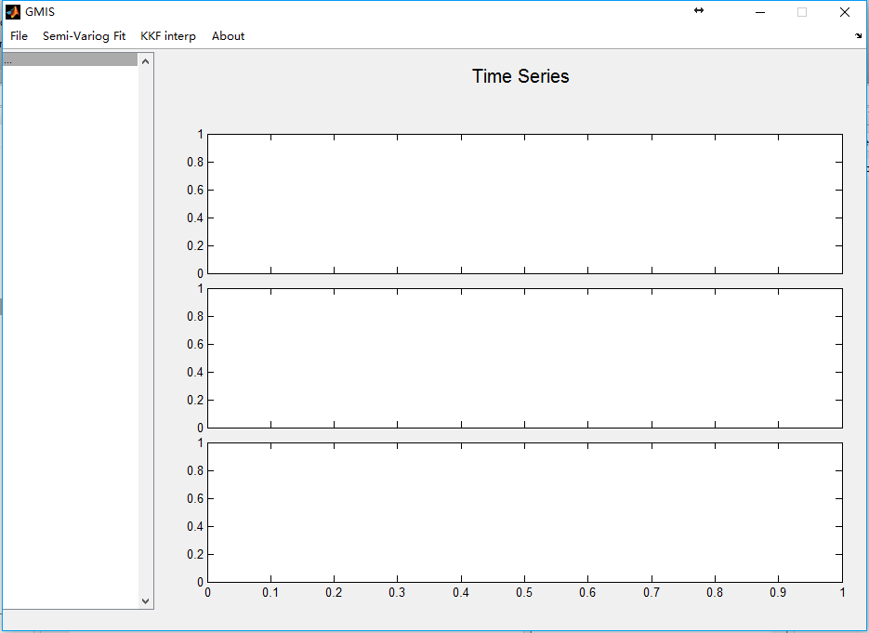

* Click *File-Open* menu, and choose the source *.mat data in the “*Select a mat file*” interface to open it:

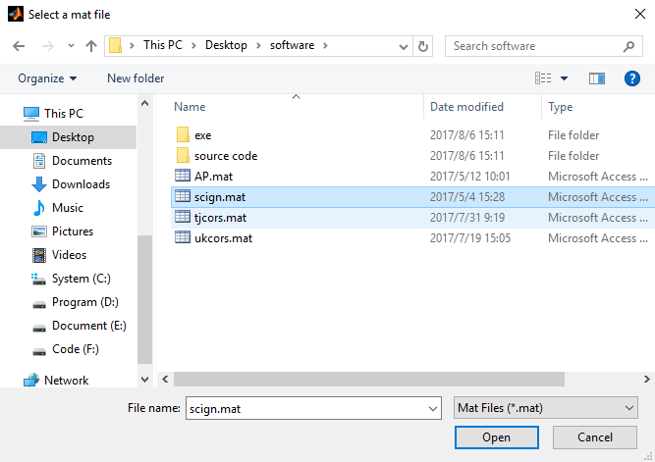

* After opening the source GNSS data, the time series will be displayed in the right axes box, and the site name will be listed in the left list box. Select one site and its GNSS time series is shown.

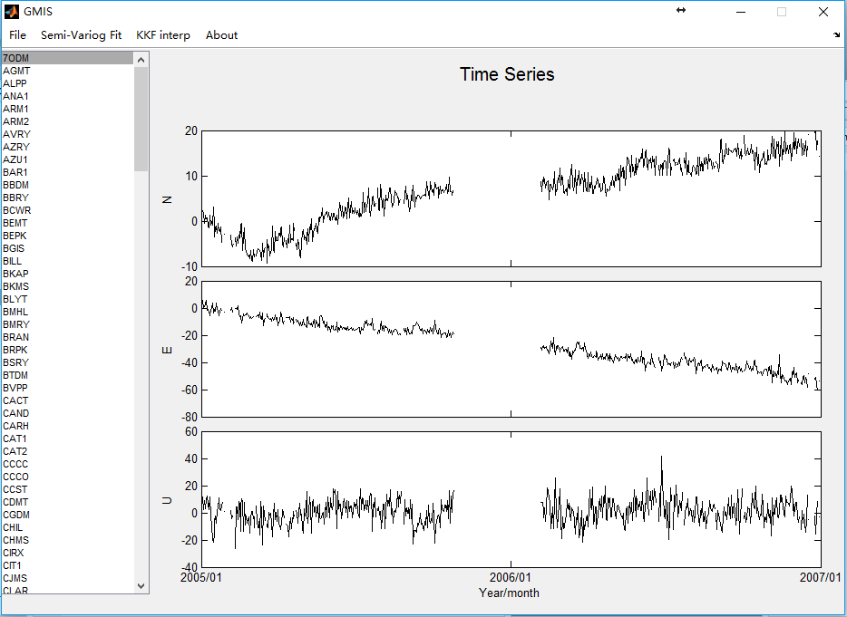

* Click the *Semi-Varig Fit* menu, then the *SemiVarigFit* GUI display figure pops up

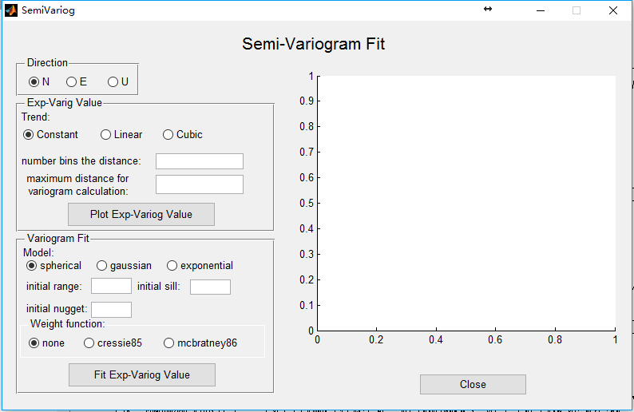

* Choose *U* direction, *constant* trend and enter 10 in *number bins in the distance* edit box and 1.6 in *maximum distance for variogram calculation* edit box. Click *Plot Exp-Varigo Value* pushbutton. The empirical semi-variogram value will display in the right axes box:

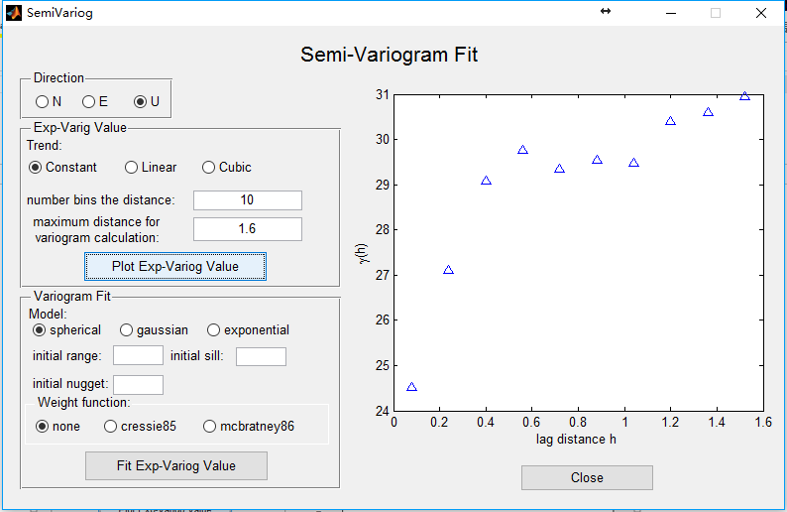

* According to the empirical semi-variogram value, choose *spherical* model, enter 0.6 in *initial range* edit box, 5 in *initial sill* edit box, 23 in *initial nugget* edit box. Select *none* for the *weight function*, then click the *Fit Exp-Varigo Value* pushbutton. The fitted semi-variogram function will show in the right axes box:

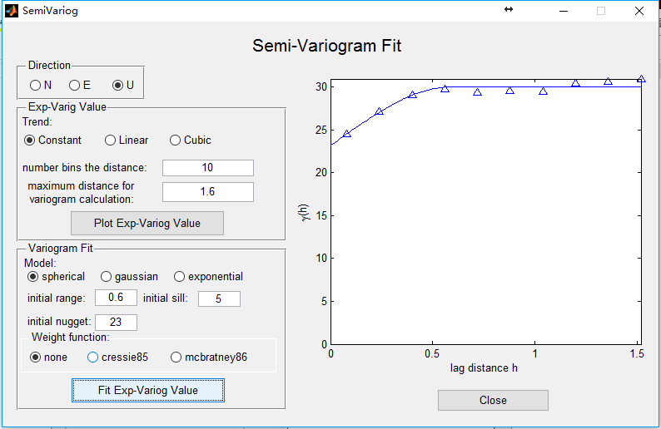

* We do not fit experimental semi-variogram value in other directions, because the fitted result of other direction does not perform well in this SCIGN time series. Click *Close* pushbutton, then the figure display will be closed. Then click *KKF interp* menu, pop-up *InterpolationMode* GUI display figure:

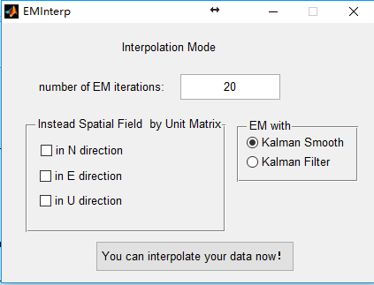

* Enter 20 in *number of EM iterations* edit box, and check *in N direction* and *in E direction* box (if the user does not check the two boxes, the software will automatically replace the spatial filed with the unit matrix, as sem-variogram function in this two direction is not fitted in this experiment). Choose the “*EM with Smooth Filter*” radiobutton. After doing this, click *You can interpolate your data now!* pushbutton. The software will start to filter and interpolate missing data:

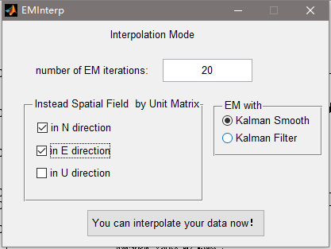

* The software will firstly start Kalman FIlter in the N direction:

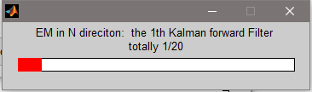

* Then, software turns to Kalman Smooth in the N direction:

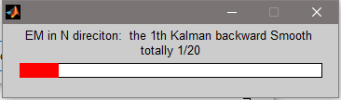

* Then, software turns to parameter update:

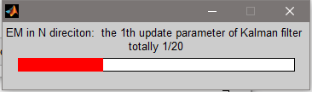

* After finishing the iteration in N direction, it will turn to the E direction automatically:

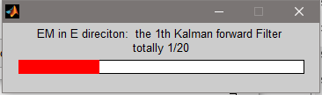

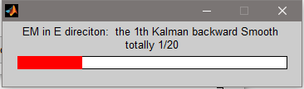

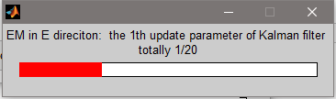

* After finishing the iteration in the E direction, software will turn to U direction automatically:

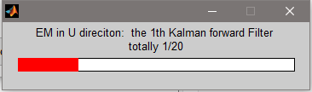

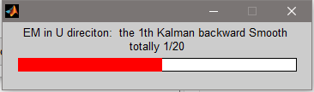

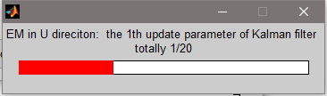

* After interpolating all missing data in all the three directions, the *InterpolationMode* GUI display figure will be closed automatically. And the filter and interpolated data will be shown in the three *GMIS* right box panel. The user can click one GNSS site in the list box to show the results of the filter and the interpolated processes:

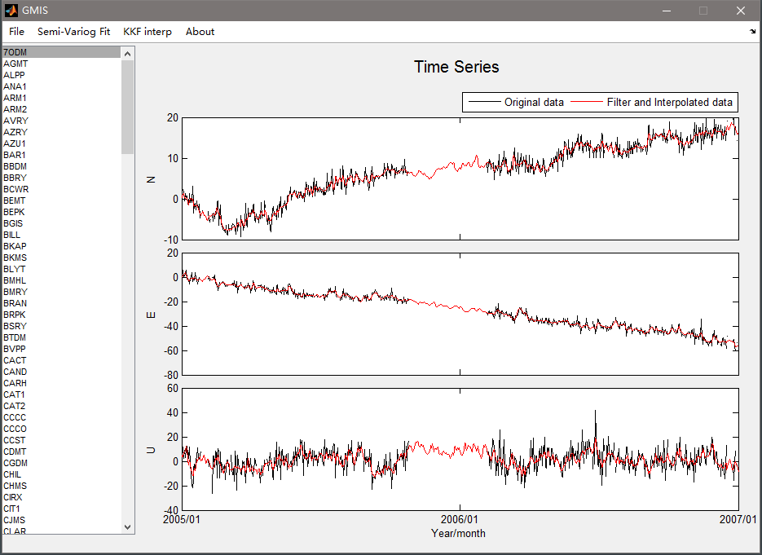

* Click *File-Save* menu, then change the save file folder and enter the file name. Click *save* pushbutton to save the result file.

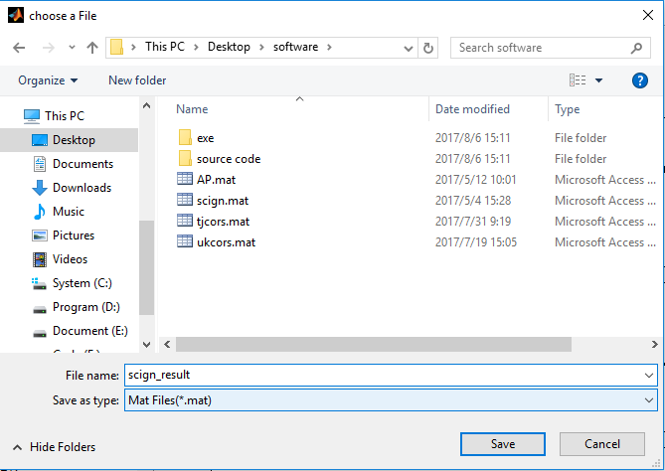

1. Example of GNSS missing data interpolation in Antarctic Peninsula

* Add GMIS software source code folder into the MATLAB search path and type GMIS in the MATLAB command window.

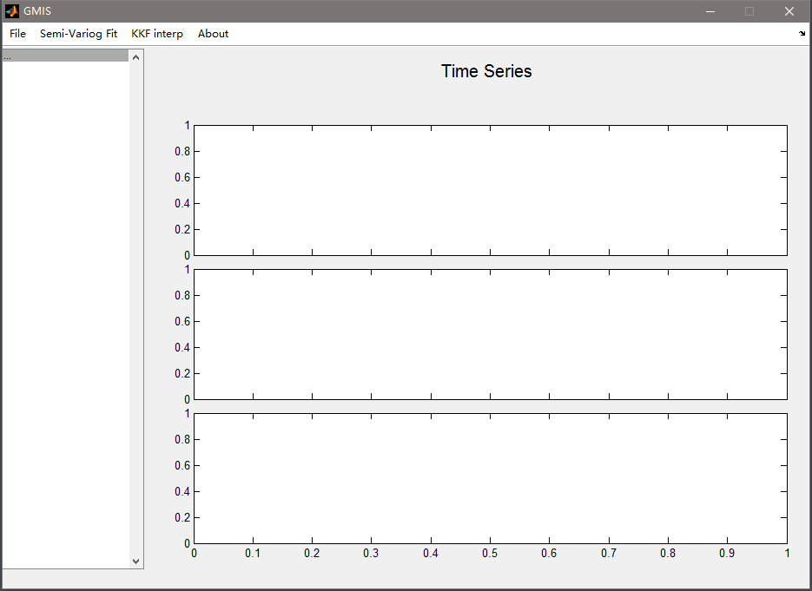

* Click *File-Open* menu, and open the source *.mat data in the “*Select a mat file*” interface.

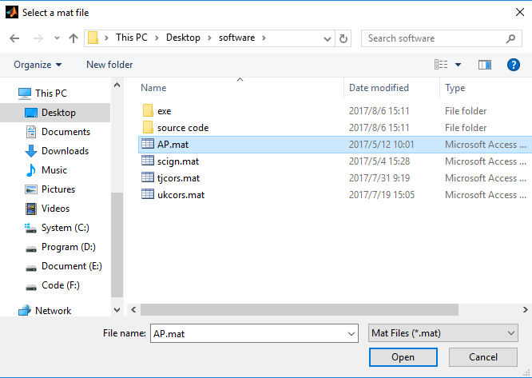

* The time series will show in the right axes box of GMIS display figure, and the site name will be listed in the left list box. Select one site and its GNSS time series shows.

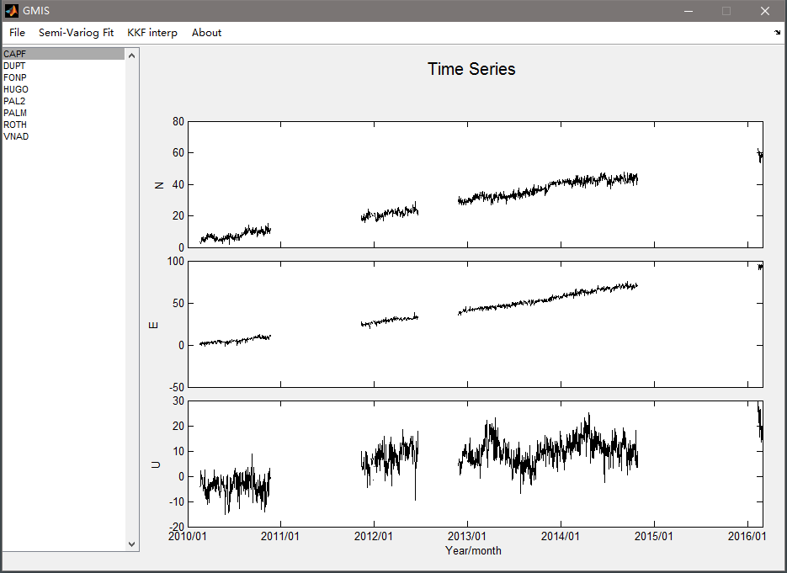

* Because of the sparse distribution of GPS sites, considering the spatial correlation is useless. Click *KKF interp* menu directly.

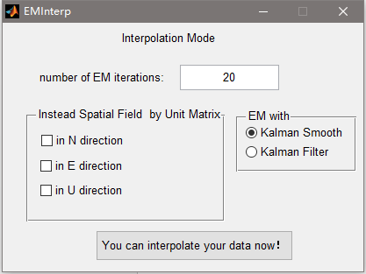

* Use the default parameters and options, then click *You can interpolate your data now!* pushbutton. The software starts to filter and interpolate missing data. The same to the SCIGN example, the software will first interpolate missing data in the N direction, then in the E direction and the U direction. After the interpolating process, the GMIS GUI will pop-up automatically. And the filter and interpolated data will be shown in the three *GMIS* right box panel.

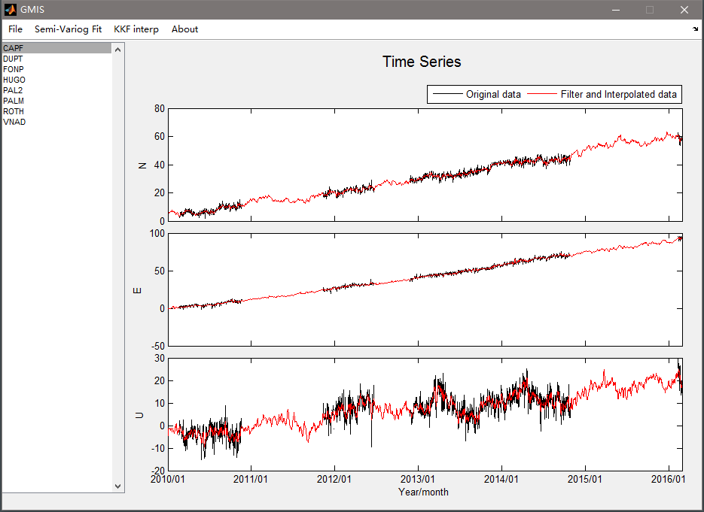

* Click *File-Save* menu, and change the save file folder. Enter the saved file name, then click *save* pushbutton to save the result file.

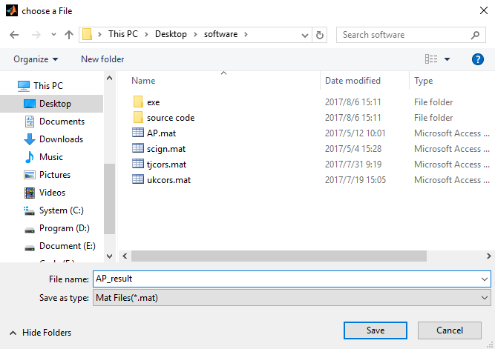

# Contact

This is the first version of this software. Please do not hesitate to contact us if you come across any bugs or have any comments, suggestions or corrections. We will reply you by e-mail as soon as possible.

Ning Liu, Wujiao Dai

E-mail: [nliucsu@csu.edu.cn](mailto:nliucsu@csu.edu.cn), wjdai@csu.edu.cn

Address: Department of Surveying Engineering & Remote Sensing

School of Geosciences and Info-Physics

Central South University, Changsha China, 410083